DOCUMENT TITLE:
UNRWA Corporate Environmental Management
- A Summary –

This summary provides a concise overview of the key findings and recommendations of the Peer Review conducted by the United Nations Environment Management Group (EMG), of the corporate environmental management of the United Nations Relief and Works Agency for Palestine refugees in the Near East (UNRWA), at their headquarters and field office in Amman, Jordan. The purpose of this summary is to convey the lessons learned and possible areas for future collaboration by other UN agencies.
For more detailed information on the report please contact the EMG Secretariat at emg@un.org
SUBTITLE 1: The Peer Review Process
The Peer Review Process was initiated in 2012 by the UN Environment Management Group (EMG). The Project aims to review the environmental sustainability profile and performance of UN and related agencies. Peer reviewing refers to one or more agencies reviewing the environmental performance of fellow agencies’ facilities and internal operations.

The Peer Review is undertaken by Peer Review Teams comprising technical experts and representatives of UN entities, international organizations and local government authorities, with support and coordination provided by the EMG Secretariat. The Peer Review Team analyses data and information provided by the reviewed agency based on site visits to the reviewed facility(ies). Achievements, challenges, good practices and lessons learned in approaches to corporate environmental management are then identified and compiled into a Peer Review Report, along with proposed recommendations. These recommendations focus on how the environmental performance of the reviewed entity could be improved whilst enhancing their resource efficiency and economic and social sustainability.

SUBTITLE 2: A Peer Review of UNRWA
The headquarters and Amman field office of UNRWA are located close to each other, with the headquarters comprising seven office blocks made up of a combination of structures built in the 1950s, 1990s and 2000s. The total area of UNRWA’s headquarters is 6404.4 m². The nearby field office is slightly smaller, at 5,560 m², with the primary function as an office building.
A 4-day site visit was conducted from 4-7 December 2016. The UNRWA review included reviewers from the EMG Secretariat, UNDP, UN Environment, UNICEF, UNOPS and the World Bank. The following topics were chosen by UNRWA to be reviewed against:
- Greenhouse gas (GHG) emissions from facilities
- Greenhouse gas (GHG) emissions from transportation
- Communication and outreach
The assessment of GHG emissions from buildings and facilities took place in the following locations: the UNRWA headquarters, the field office, the transportation hub, a sample school and a sample health clinic. The land transportation-related GHG emissions assessment was confined to the transportation hub managed by UNRWA.
Greenhouse Gas Emissions from Facilities
SUBTITLE 1: Status
Headquarters
Electricity consumption peaks during the month of August, i.e. the hottest month in Amman: this peak is likely a result of a peak cooling load around this time. During the winter months of January and February, a reversible air-conditioning system provides heat to the building in addition to the heat provided by diesel boilers in the facility.
Lighting in the headquarters office building is made up of fluorescent bulbs with 36 Watts per tube. Each fixture has a reflective surface for better light distribution. The small power load (from plug use), comprises a mixture of desktops and electronic notebooks. All toilets are equipped with a hot water tank to provide hot water for hand washing.
Electricity consumption per month in 2015 and 2016 (Headquarters)

Some 24% of the annual energy costs borne by UNRWA are accounted for through office cooling, whilst 5% can be attributed to plug loads in the corridors (including large printers, water dispensers and hot water for toilets). At the same time, indoor lighting (offices and corridors) amounts to 27%, whilst outdoor lights result in 2% of energy costs.
Percentage of energy costs distribution (Headquarters)

Offices
Most lighting in the field office has been changed to LED tubes that have approximately 50% lower power consumption than previous installations. The annual energy consumption of the field office, per m², is 20% lower than that of the headquarters. The field office has a fresh air supply system flowing into the corridors, with the original purpose of this system being to allow the fresh air to be infiltrated into the office spaces and ex-filtrated out of the office windows.
The measured CO₂ level in the field office was low, even with this fresh air supply system switched off. Such an indication suggests that the building’s air infiltration rate is quite high and that it is not necessary to operate the fresh air system because it would increase fan-energy use without necessarily improving the air quality.
SUBTITLE 2: Achievements
Some of the fluorescent lights in the Amman field office have been replaced with LEDs. These LEDs have some 50% lower energy consumption; an energy efficiency improvement that can be seen from the energy bill itself as the field office has a 20% lower specific energy cost as compared to the headquarters. The field office has also seen a wider replacement of the water faucet fittings with low-flow types that reduce water use by more than 50% for each fitting.
In the headquarters, many lights in the corridors are switched off during the daytime in places where daylight is adequate. Moreover, motion and daylight sensors have been installed in parts of the facility.
The previous older non-inverter split air conditioning units were replaced with more energy efficient inverter-type split units throughout the UNRWA facilities. Inverter-type units are beneficial for controlling and continuously regulating the temperature, and generally have increased efficiency compared to traditional air conditioners. The replacement of older, traditional split units that have reached (or near) their lifespan, is an ongoing process in UNRWA.
SUBTITLE 2: Challenges
Corporate culture
Like in many other large organizations, there is an unintentional culture of energy wastage at UNRWA. Employees in large organizations often see it as a rightful entitlement to use as much energy as necessary at work. The unlimited use of energy is perceived as a part of the employment package to ensure productivity in the office. Any attempts at removing this perceived entitlement will often be met with objection.
Expertise
There is one electrical engineer who has contributed to energy efficiency processes at UNRWA. The energy efficiency in a building also involves a comprehensive understanding of mechanical systems such as heating, cooling pumps and fans; of electrical system such as lighting and of architectural aspects like passive heating and cooling, daylight harvesting and air tightness. These mechanical systems, including energy efficiency technologies, are rapidly changing and progressing.
SUBTITLE 3: Recommendations
Improving lighting efficiency and daylight harvesting
In general, UNRWA offices were measured to be overly lit. De-lamping, energy efficient lights and the use of daylight were identified to reduce buildings’ total energy consumption by more than 10%.
Improving boiler system efficiency
Boilers that operate at a high temperature change will improve efficiency, which can be achieved through better operational control of the boiler pumps. Additional small-scale measures such as proper pipe insulation, reduced operating hours and replacement of the radiator’s control valve with temperature sensors will further reduce overall building energy consumption.
Data centre improvements
It is recommended for UNRWA to operate the data centre at no lower than 25⁰C instead of the current 20⁰C - 22⁰C. Additionally, the data centre should consider the use of free cooling with outdoor air, whenever the air outside is cooler than 23⁰C.
Improving energy management of office equipment
Desktop computers are a large contributor to the total building energy use. An increased use of notebooks and the implementation of power management on desktop computers will significantly reduce energy consumption in office buildings. Furthermore, a weekly timer that can switch off printers, water dispensers and heating for hand washing has proven to provide a small amount of energy reduction too.
Energy manager
An appointment of a permanent energy manager within UNRWA with an appropriate background in energy efficiency in buildings will make a significant overall energy reduction in UNRWA. If a 5% energy cost reduction can be achieved from the headquarters’ current total estimated JD2.6 million per year cost, then a budget of JD130,000 per year is possible and could cover the employment of an energy manager.

Greenhouse Gas Emissions from Transportation
SUBTITLE 4: Status
At the transportation hub, the offices are small and sporadically located and there are very few people working there. The vast majority of the 217 vehicles at UNRWA belong to the Amman field office, which also exhibits the highest number and percentage of diesel vehicles. The types of vehicles at UNRWA differ according to use and they include buses, trucks, sedans and 4x4 vehicles. Each of these vehicle types exhibits a different fuel efficiency, emission profile and fuel requirement. There is also a noticeable variability in fuel efficiency within the same type of vehicles when comparing the vehicles belonging to different entities in UNRWA. The fuel requirements of the field office vehicles are expressed as liters per 100 kilometers.
Fuel consumption of various vehicle types in Jordan Field Office (based on data of the last 2 years)
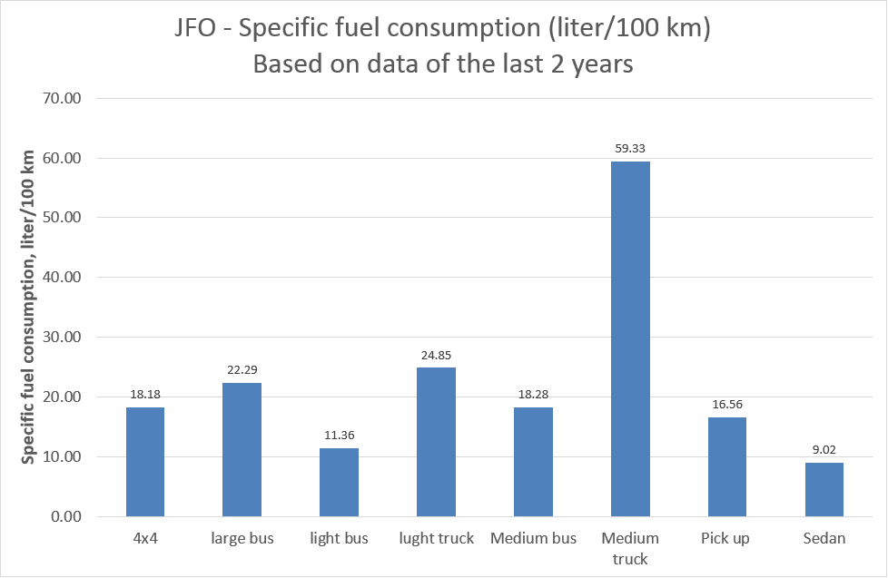
For the same class of vehicle, a higher fuel consumption was recorded at the different UNRWA departments – sedans and medium buses were reviewed. The variability in fuel efficiency within the same type of vehicles is best seen in the following graph, which shows fuel efficiency for medium buses and sedans that vary by approximately 10% and 60% respectively, per UNRWA department: Jordan Field Office (JFO), Amman Training Centre (ATC) and Wadi Seer Training Centre (WSTC).
Sedan specific fuel use (liter/100km)
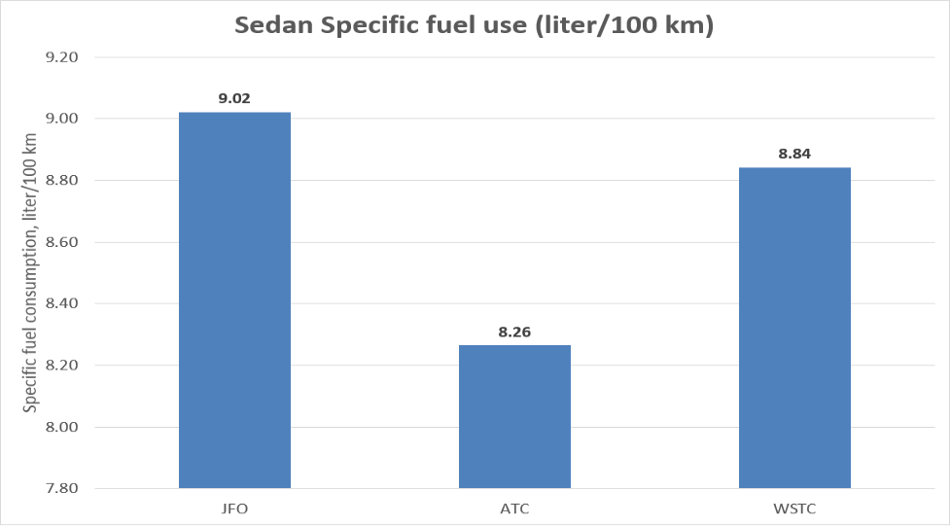
Medium bus specific fuel use (liter/100km)
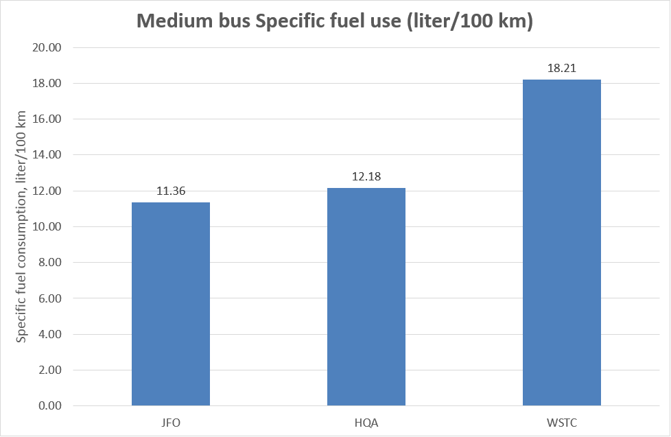
The variation in fuel in sedans and medium buses, across the three studied UNRWA departments, suggests that vehicle fleets could be run more efficiently and that the higher fuel consumptions for the same class of vehicles could be due to:
- The age difference in the same class of vehicles with the older vehicles typically being more inefficient and requiring more maintenance.
- Driving habits among WFP drivers will make a huge difference to fuel efficiency. A driver making rapid stops and accelerations will wear out the car and will consume much more fuel for the same distance covered.
- The driving routes taken, depending on terrain and traffic, will lead to a variation in fuel efficiency.
- Inaccurate or fraudulent fueling practices inevitably lead to ‘fuel efficiency’ discrepancies. For example, practices at the fueling station that should not occur – such as filling extra fuel cans – can affect fuel economy. It is assumed that WFP has checks to mitigate such practices.
SUBTITLE 5: Achievements
The vehicle maintenance operation is well managed and a vehicle management system is in use. The vehicle management system provides data detailing each vehicle’s repair history, fuel consumption and frequency of use.
SUBTITLE 6: Challenges
Access over ownership
At UNRWA, owned, self-maintained and self-operated vehicles resulting in a cost of JD2.4/km are potentially more expensive to run in comparison to JD2.2/km for leased and rented vehicles. It is difficult in Jordan to dispose or sell vehicles, as duty-free vehicles do not have their tax depreciated, making them expensive to sell.
The absence of catalytic converters:
Vehicles without a catalytic convertor will emit toxic pollutants. Unleaded fuel was only introduced in 2008, in Jordan. Many existing vehicles from this period had their catalytic converters removed due to the leaded fuel clogging up the converter. Without it, there is a risk of toxic emissions being released.
High Sulphur content in Jordanian diesel:
The standard diesel fuel in Jordan has a high level of sulphur oxides (SOx of 12,000ppm), whereas in Europe and America it must be kept at 15ppm. High levels can be damaging to human health. In addition, Sulphur can have negative effects on engine life, as highlighted below.
SUBTITLE 7: Recommendations
Vehicle leasing
As well as cost savings, vehicle maintenance is outsourced and included in the lease, which frees up valuable staff time and resources at the workshop. Leasing means that the vehicles are eventually returned, meaning that their end of life/use management is made easy. Vehicle leasing is currently practiced by the World Food Programme in Jordan.
Fleet sharing scheme
Field missions in developing countries that have been exploring fleet sharing options have shown to save some 20% of the vehicles needed, whilst at the same time drivers are kept busy. Whilst it would require the use of fleet software and management tools, pooling vehicles in UNRWA alone could potentially save about 30 saloon vehicles and their more frequent use would also translate into a newer fleet as the cars reach their end of life sooner.
Driver training
It could be possible to save up to 10% of fuel usage by training drivers in eco-driving, which could equate to roughly JD70,000 per annum for UNRWA. Fleet software can also track driver behaviour, including their location and safety.
Working catalytic converter:
All gasoline vehicles should have a working catalytic converter in place. Given that unleaded fuel is now ubiquitously used in Jordan, these devices can operate properly and need not be removed.
Reduced Sulphur levels
UNRWA should be in a position to negotiate and obtain 350 Ppm-Sulphur diesel fuel. The availability of the amounts and costs of this should be ascertained. 350 ppm diesel will make a big difference to the emission levels from diesel vehicles.
More vehicle emissions testing
An annual carbon-monoxide tail-pipe test for gasoline vehicles and a simple opacity test of effluent from diesel vehicle tailpipes should be carried out. Probes can be used and are easily obtainable for the test, whilst an opacity test can be undertaken by checking the emission colour or shade against a chart. These emissions tests should be a simple and cheap enough method of ascertaining the performances of catalytic converter engines.
Communication and Outreach
SUBTITLE 8: Status
A successful communication and outreach programme will ensure a smooth transition to an energy efficient organisation. Buy-in from all levels of an organisation is required to implement long-term improvements in building GHG emissions. A comprehensive communication and outreach programme should be made a part of UNRWA’s strategy to improve its GHG emissions.
SUBTITLE 9: Achievements
The existence of dedicated staff in the UNRWA headquarters and field office that have committed to improving sustainability within the organisation is an exciting beginning. These staff are ideal candidates to be the champions moving forward, for GHG emissions reduction at UNRWA.
SUBTITLE 10: Challenges
Tariff review
Currently electricity metering in UNRWA is calculated based on a residential tariff, which has a very high cost per kWh, after a comparably low fixed amount of energy consumption per month. This tariff is meant for residential houses with a typical occupancy amounting to ten persons, whereas in UNRWA, more than 500 persons occupy the space.
Motivation, technical information and awareness
Occupants’ behaviour plays a big role in ensuring the success of energy efficiency implementation in any existing building. Implementation will fail when occupants choose to bypass technologies that promote efficiency and sustainability.
Most staff are generally unaware of the many health benefits of an energy efficient building. Many are also unaware of the abundant technical opportunities that are available to reduce buildings’ GHG emissions.
Funding information and awareness
In the absence of knowledge regarding the costs involved in adopting energy efficiency measures and the way to calculate the direct and indirect savings, it is difficult to properly assess the cost-effectiveness of the payback period for such an investment. There is currently no specific fund for GHG emissions reduction in UNRWA.

SUBTITLE 11: Recommendations
Change to commercial tariff
A change of tariff to a conventional office, commercial tariff will provide significant immediate energy cost reduction.
Appointing champions
There may be a need, at UNRWA, to appoint a minimum of one person as GHG emissions reduction champion in each facility to lead the communication and outreach programme on this topic. Through education, providing consistent information and awareness could lead to long-term understanding of GHG-related issues for an organization.
Behavioural change
An employees’ motivational programme must be implemented to drive behavioural change. Mental barriers such as “someone else will save the planet” and “my contribution is just too small to count” etc., all need to be openly discussed.
Health benefits
Many energy efficiency implementations also yield better environmental quality that improves occupants’ health. Access to daylight improves productivity during the daytime, whilst access to adequate outdoor clean and fresh air improves oxygen levels and daytime alertness.
Technical information, awareness and funding
Awareness programmes on energy efficiency issues such as phantom load, the selection of efficient lighting, the selection of heating and cooling equipment etc., is valued by employees because it will help to reduce energy costs at home as well as in the office. Information on funding mechanisms should be disseminated to the relevant parties to allow departments to implement GHG emissions projects on their own, where possible

