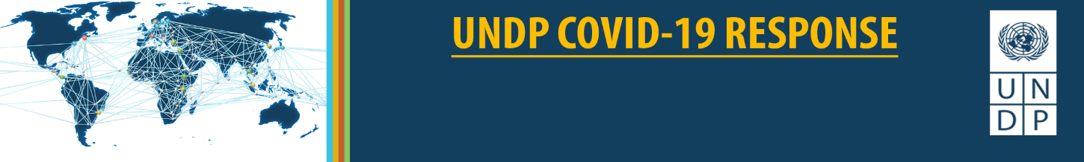
NATURE, CLIMATE, AND ENERGY

NATURE, CLIMATE, ENERGY AND COVID-19

“Our economies, our societies, our communities have to rediscover how to live with nature. And how they do that in the coming years will in large part determine whether the magnitude of pandemics, natural disasters, crises become more and more intense, or whether we can reestablish a degree of coexistence with nature that actually stabilizes our communities, our societies, our economies, and therefore becomes a way of thinking about the future of development with different parameters.”
- Achim Steiner, UNDP Administrator, April 9th 2020

UNDP’s Nature, Climate and Energy response is integrated within UNDP’s larger strategy for preventing, responding to, and recovering from the pandemic with a focus on addressing the needs of women and men living in poverty and other vulnerable groups. It is designed to respond to the health crisis, mitigate the risk of future pandemics, and build back better by addressing the broader set of linked nature, climate, energy, socio-economic, governance and crisis issues.

The combination of COVID-19 and the dual Nature and Climate crises dramatically multiplies the risks to vulnerable communities. Environmental degradation and climate change could make these outbreaks more frequent. UNDP’s interventions are geared towards helping governments to find solutions so that the recovery can be environmentally sustainable, climate-sensitive, energy efficient, and long lasting. This will allow for more strengthened livelihoods, resilient rural-urban planning, climate-friendly technologies, and environmental sustainability.

Recovering from this pandemic must not come at the expense of tackling other global crises. UNDP will help to scale-up and incentivize environmentally sustainable and climate responsive growth models. The socio-economic impact of COVID-19 is already affecting billions of lives directly linked to the management of natural resources. UNDP will incorporate special measures to increase resilience of these communities who act as custodians of conservation and climate action against shocks including future pandemics and their socio-economic impact.

Biodiversity friendly, low carbon, green growth is possible. UNDP will help to ensure that economic and social recovery efforts will embed measures to accelerate nature and climate actions. We will help countries and communities to “build back better” by investing in systemic changes needed to accelerate SDG progress. Integrated inclusive green economy approaches can yield a significant amount of sustainable jobs and enterprises, while also ensuring that our growth stays within planetary boundaries. UNDP will also ensure climate-resilient, environmentally sustainable health care systems including medical waste management and water and sanitation.

A more detailed summary of UNDP’s Nature, Climate and Energy response follows. This integrated response leverages UNDP’s existing portfolio of advocacy, policy and programming. It also identifies opportunities to advance new and emerging initiatives and partnerships.

COVID-19 and Nature

PREPARE: UNDP is helping countries to identify and assess high-risk factors for the emergence of zoonotic diseases linked to biodiversity loss, livelihoods, and wildlife consumption and trade.

RESPOND: UNDP will help countries to slow the spread of the virus and provide social protection for vulnerable populations, including conservation and livelihood support staff in the field and communities dependent on wildlife-based tourism.

RECOVER: UNDP will support countries to assess the social-economic-environmental impacts of COVID-19 including through repurposing of harmful subsidies, and “greening” stimulus packages.
UNDP will also mitigate the risk and impact of zoonotic disease outbreaks by addressing their root causes including destruction and degradation of natural areas and ecosystem services, illegal wildlife trade, and risks associated with wildlife consumption and livestock farming.

COVID-19 and Climate Action

RECOVER:
NDCs - UNDP will provide support to enhanced Nationally Determined Contributions (NDCs) adjustments for COVID-19.

Climate Change Adaptation- UNDP will identify opportunities for investments in long-term resilience building to address co-vulnerabilities of the climate and health crises.

Climate Change Mitigation- UNDP will: 1) support the development of COVID-19 responses that include clean energy investments to enhance NDCs and long-term decarbonization strategies; and 2) help tropical forest countries to recover without increased forest cover loss.

COVID-19 and Energy

PREPARE: To strengthen countries’ first line of defense against the pandemic, UNDP can support the electrification of existing and temporary health facilities.

RESPOND: To help countries slow the spread of the virus and provide social protection for vulnerable populations, UNDP can support multi-sectoral efforts to ensure continuity of power supply and access to energy for vulnerable populations.

RECOVER: To help countries recover from the economic and social impacts in the months to come, UNDP can support efforts to leverage sustainable energy infrastructure investments to speed-up recovery and to seize opportunities to reform fossil fuel subsidies (FSS).

COVID-19 and Sustainable Health Care Systems

PREPARE AND RESPOND: UNDP will strengthen national health care waste management systems by upgrading and installing protective equipment and waste treatment technologies, and training of health care workers to reduce levels of exposure.

RECOVER: Broader “One Health” System Approaches - UNDP will help advance a multisectoral approach to ensuring better health outcomes through support to environmentally sustainable, climate-resilient health care systems. This work will include a focus on communicable and non-communicable diseases through better access to water and sanitation, and other efforts that address the links between people, animals, plants, and their shared environment and climate.

