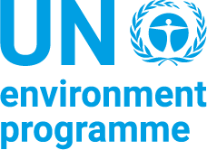
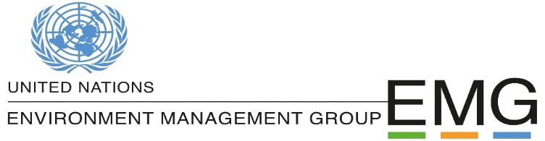

DRAFT
Supporting the Global Biodiversity Agenda - We are part of the Solution
A United Nations system commitment for catalysing collective action for nature.

Online Event - 25 May 2021, 15h00 -16h30 CET

Making peace with nature is the defining task of the 21st century. It must be the top, top priority for everyone, everywhere.
António Guterres, UN Secretary General

The COVID-19 pandemic underscored the extraordinary interconnectedness between human, animal and environmental health, and how this underpins global peace and the stability of our socioeconomic systems. As countries act to recover, there is growing momentum for the UN to demonstrate concerted action, through its convening power and leveraging of expertise across the system. By developing stronger and more coherent knowledge-based resources, the UN system can support action for the 2030 Agenda for Sustainable Development and the delivery of the post-2020 global biodiversity framework.
In May 2021, the United Nations System Chief Executives Board for Coordination (CEB) endorsed a common approach to integrating biodiversity and nature-based solutions for sustainable development into the UN policy and programme planning and delivery. Through this common approach, the UN system commits to mainstream biodiversity and catalyse collective action to address the drivers of and restore biodiversity in view of achieving the 2050 vision of ‘living in harmony with nature’.
This builds upon previous commitments by representatives from 51 UN entities which, under the auspices of of the UN Environment Management Group, prepared a report that defines a roadmap with timely actions to support governments and relevant stakeholders in delivering on a decade of action for biodiversity.
As countries commit to develop an ambitious post-2020 global biodiversity framework to be adopted by the Convention on Biological Diversity this year, the UN stands ready to support bold leadership and urgent action across the whole of government and society which is required to address biodiversity loss while putting nature on a path to recovery by 2030. The start of the UN Decade of Action to deliver the SDGs, as well as the UN Decades on Ecosystem Restoration, on Family Farming and on Ocean Science for Sustainable Development provide opportunities for engagement to accelerate the delivery of agreed international measures and achieve progress towards inclusive sustainable development.

Event outline
Moderator: Ms. Ameenah Gurib Fakim, former President of Mauritius
15:00 – 15:10 | Introductory remarks  - Ms. Ligia Noronha, UN Assistant Secretary-General and Secretary of the Environment Management Group
15:10 – 15:30 | Keynote addresses: what are the key systemic challenges in integrating biodiversity for sustainable development?  - H.E. Ms. Yasmine Fouad, Minister of Environment of Egypt, President of CBD COP 14  - Mr. Liu Ning, Deputy Director General, Department of Nature and Ecology Conservation, Ministry of Ecology and Environment of China, Host Government of CBD COP 15
15:30 – 15:40 | Audience engagement: Online survey on Menti.com  - How can the UN system contribute more effectively to the implementation of agreed global commitments and national priorities needed to set the world on path towards a more sustainable and equitable future with a focus on biodiversity which provides the foundation for life on Earth?
15:40 – 16:20 | Panel discussion: From Commitments to Action – Accountability and Engagement for transformative system change to halt the loss of and restore biodiversity  - Ms. Inger Andersen, Executive Director, United Nations Environment Programme (UNEP)  - Ms. Michelle Bachelet, UN High Commissioner for Human Rights  - Mr. QU Dongyu, Director-General, Food and Agriculture Organization (FAO)  - Ms. Shamila Nair Bedouelle , Assistant Director General, United Nations Educational, Scientific and Cultural Organization (UNESCO)  - Mr. Samba Thiam, Senior Development Policy Advisor to the Administrator, United Nations Development Programme (UNDP)
16:20 – 16:30 | Conclusions and next steps  - Ms. Elisabeth Maruma Mrema, Executive Secretary of the Convention on Biological Diversity (SCBD) – Video Message  - Ms. Ligia Noronha, UN Assistant Secretary-General and Secretary of the EMG

Biographies of the other panelists
Moderator:
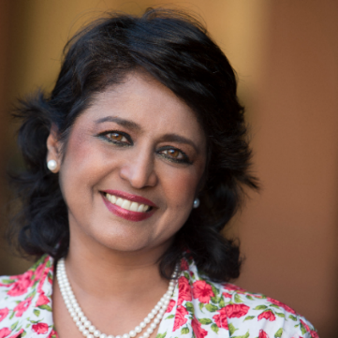
Ms. Ameenah Gurib Fakim, former President of Mauritius
Ms. Gurib-Fakim was the first female president of Mauritius, serving for a three-year period from 2015 - 2018. Prior to this appointment, she was the managing director of the CIDP, a company specializing in clinical research, alongside holding a chair in organic chemistry at the University of Mauritius. Ms. Gurib-Fakim has a wide range of publications including scientific articles on biodiversity conservation and sustainable development, with additional experience in environmental issues from consultations for the World Bank, SIDA, CIDA, EU and the UN. Ms. Gurib-Fakim has also been the recipient of various awards including the 2007 L’Oreal-UNESCO Award for Women in Science and the Laureate for the National Economic and Social Council.

Ms. Ligia Noronha, Secretary of the Environment Management Group and Head of UNEP NY Office
Ms. Noronha is an economist with over 30 years of international experience in the field of sustainable development. In 2014 she was appointed Director of UNEP’s Economy Division based in Nairobi leading the UN Environment’s sub-programmes on chemicals and waste, resource efficiency and climate change. Prior to joining UNEP, Ms. Noronha served in The Energy and Resources Institute (TERI) as Executive Director (Research Coordination) and as Director of the Resources, Regulation and Global Security Division. Ms. Noronha has published internationally on emerging issues relevant to energy and resource security, climate change and environmental policy.

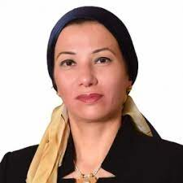
Keynote addresses:
H.E. Ms. Yasmine Fouad, Minister of Environment of Egypt, President of CBD COP 14
H.E. Ms. Yasmine Fouad was appointed the minister of the Environment of Egypt in 2018, previously being the assistant minister of the Environment since 2014. Ms. Fouad played a key role in advancing the biodiversity Agenda and leading the development of the Post-2020 Global Biodiversity Framework as president of the 14th CBD COP14. She has over 20 years of experience in the environment and international cooperation, working in government, UN organizations, NGOs and Universities. Previous work includes supporting the Earth Institute in designing a centre of excellence for adaptation to climate change, and managing climate change initiatives at AMCEN.

Mr. Liu Ning, Deputy Director General, Department of Nature and Ecology Conservation, Ministry of Ecology and Environment of China, Host Government of CBD COP 15
Mr. Liu Ning is currently the Executive Director of the Office of the Executive Committee for the 15th meeting of the Conference of the Parties to the Convention on Biological Diversity (COP15) and Negotiator of Chinese delegation. He was a Researcher at Chinese Academy of Environmental Sciences, Visiting Scholar to Georgia Institute of Technology (US), Consultant to Netherlands National Institute of Marine and Coastal Zone, core expert of the Asia-Europe Centre for Environmental Technology, European Division Chief of International Cooperation Department of the Ministry of Environmental Protection, Deputy Permanent Representative of China to the United Nations Environment Programme.

Panel discussion:
Ms. Inger Andersen, Executive Director, United Nations Environment Programme (UNEP)
Ms. Inger Anderson is the under-Secretary-General of the United Nations and Executive Director of the United Nations Environment Programme. Her previous positions include being the Director-General of the International Union for Conservation of Nature (IUCN), and several leadership positions at the World Bank including Vice President for Sustainable Development. Ms. Anderson has over 30 years of experience in international development economics, environmental sustainability, strategy and operations.

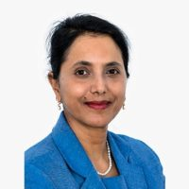
Ms. Shamila Nair-Bedouelle Assistant Director-General for Natural Sciences, UNESCO
Ms. Nair-Bedouelle Born in 1960, Shamila Nair-Bedouelle holds a PhD in Life Sciences from the University of Capetown in South Africa. She pursued her research career at the Institut Pasteur in Paris from January 1992 onwards then within the pharmaceutical industry at the MIT University Park in Boston, USA, from January 1994 until January 1996, when she integrated the French National Institue for Medical Research (Institut national de la santé et de la recherche médicale, INSERM). She has published in numerous scientific journals and is the co-inventor of several patents. Dr Nair-Bedouelle has pursued her research interests in parallel to her career at the United Nations. She has been Director of Research at the University of Paris V in France since 2000 and was nominated First Class Director of Research at INSERM in 2017.
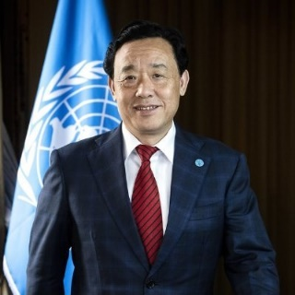
Mr. QU Dongyu, Director-General, Food and Agriculture Organization (FAO)
Mr Qu Dongyu was appointed as the Director-General of the Food and Agriculture Organization of the UN in 2019 and is the first Chinese national to head the Organization. Between 2011 and 2015 Mr Dongyu served as Vice-Chair of the Ningxia Hui Autonomous Region in China and in 2015 he became Vice-Minister of the Ministry of Agriculture and Rural Affairs, where he was involved in promoting international collaboration with organizations such as FAO.

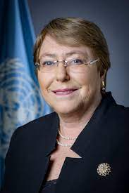
Ms. Michelle Bachelet, UN High Commissioner for Human Rights
Ms. Michelle Bachelet is a Chilean politician who has served as United Nations High Commissioner for Human Rights since 2018. Ms. Bachelet’s previous positions include election as the President of Chile on two occasions (2006 – 2010 and 2014 – 2018), being the first female president of Chile. She has also served as Health Minister (2000 - 2002) as well as Chile’s and Latin America’s first female Defense Minister (2002 – 2004). Ms. Bachelet was additionally the inaugural Executive Director of The United Nations Entity for Gender Equality and the Empowerment of Women in 2011.
Conclusions and next steps

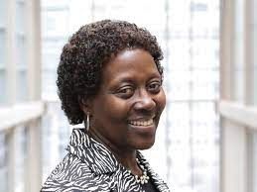
Ms. Elisabeth Maruma Mrema, Executive Secretary of the Convention on Biological Diversity (CBD) (recorded Video Message)
Ms. Elizabeth Maruma Mrema was appointed as the Executive Secretary of the Convention on Biological Diversity in 2020 and is the first African woman to hold this role. Prior to this appointment, Ms. Mrema had worked with the UN Environment Programme for over two decades in a variety of roles including Deputy Director of the Ecosystems Division, Law Division Director, and Acting Director of the Corporate Services Division. In 2009 Ms Mrema was also appointed Acting Executive Secretary of the UNEP/ASCOBANS, Executive Secretary of the UNEP/CMS, and Interim Executive Secretary of the UNEP/Gorilla Agreement. Before beginning work with UNEP, Ms. Mrema worked for Tanzania's Ministry of Foreign Affairs and International Cooperation.

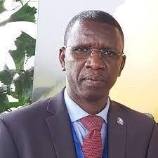
Mr. Samba Thiam , Senior Advisor to the UNDP Administrator
Former UNEP head of office in Ethiopia

