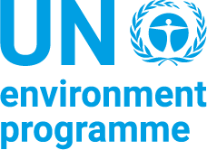
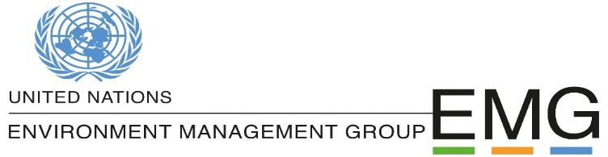

Draft Terms of Reference for the EMG Issue Management Group on Biodiversity

Background
Since early 2020, the world has been upended by a global pandemic. COVID-19 has highlighted the catastrophic consequences that continuous pressure on natural ecosystems can have for human health, livelihoods and economies. In March 2020, the Secretary-General called on the UN system to mainstream biodiversity in key areas, engage in cross-agency collaboration and enhance UN communications and advocacy. This was carried forward by Chief Executives Board for Coordination (CEB) through a process referred to as the UN Common Approach on biodiversity and nature based solutions.

The UN Common Approach builds on the work of the UN Environment Management Group, which in September 2019 established a Consultative Process on Biodiversity with representatives from 51 international agencies coming together to draft a report entitled “A UN System Commitment for Action to assist Member States delivering on the post-2020 Global Biodiversity Framework (GBF).

Both outputs further point to the need to mainstream biodiversity and catalyse action required to halt the loss and restore biodiversity by addressing the drivers of biodiversity loss and ultimately ‘making peace with nature’ as mandated by the UN Secretary-General.

Building on the contributions consolidated through the EMG Consultative Process, the UN Common Approach provides the normative framework in a result-based structure to organise collective action and joint delivery to mainstream biodiversity and nature-based solutions. It elaborates 15 medium-term objectives or expected accomplishments that contribute to the realization of the 2050 vision of living in harmony with nature. These are the longer-term transitions beyond the common approach’s direct outcomes, and should be pursued in partnership with government, business and civil society. They set the overall strategic intent of the common approach, and each contribute to at least one of the three impact areas: (i) human rights, peaceful societies and planetary stability; (ii) a green and inclusive economic recovery; and (iii) strengthened institutions, accountability and justice as depicted in Figure 1.

Figure 1: Normative Framework to Mainstream Biodiversity

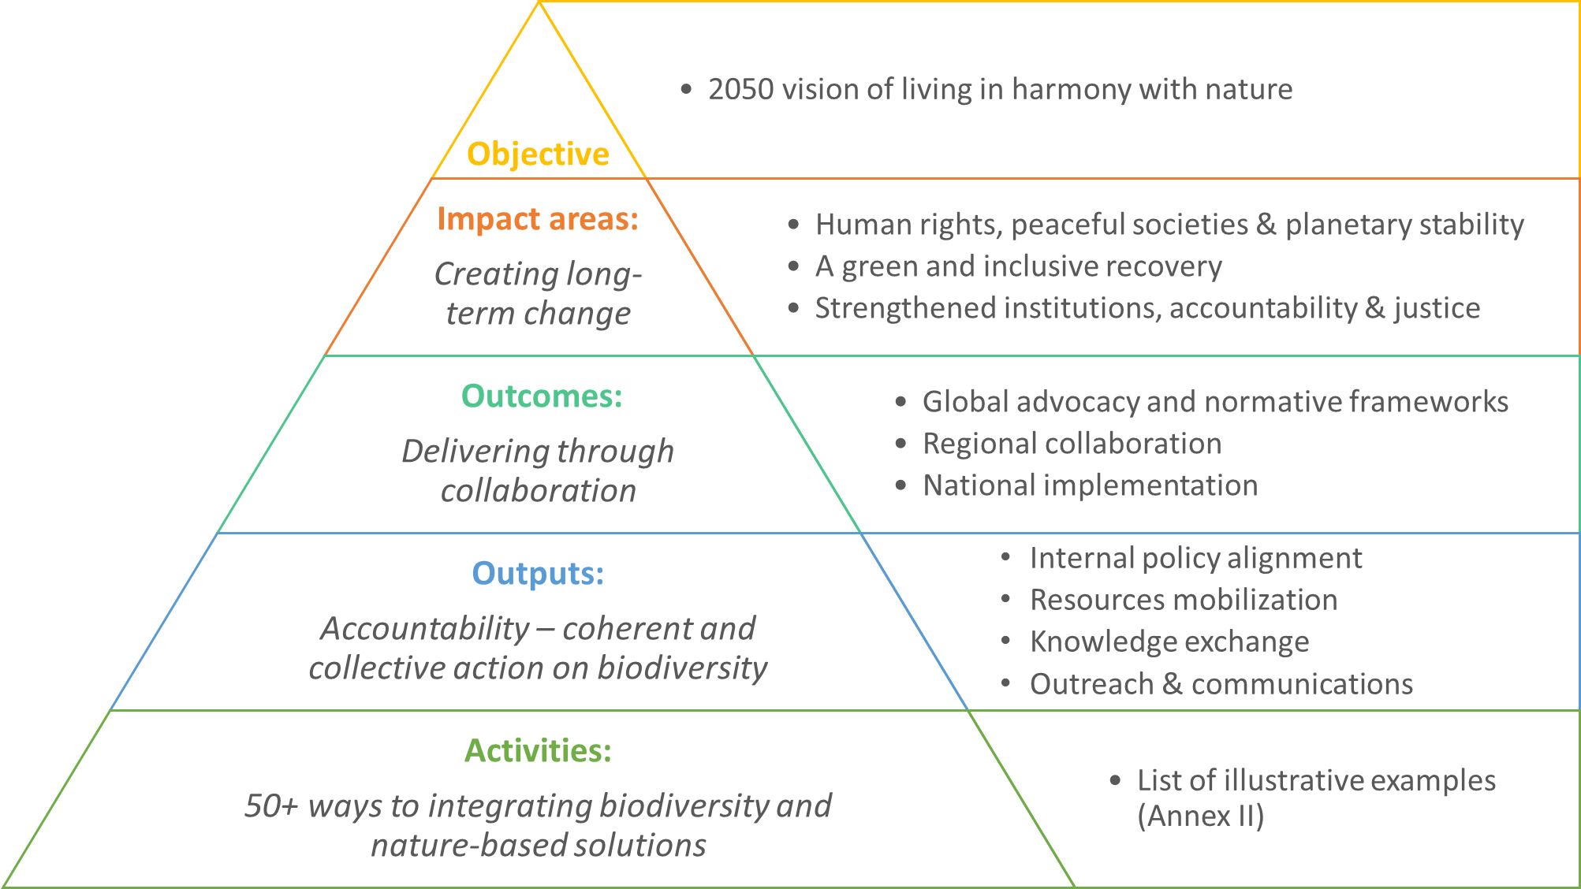

Both the UN Common approach and the EMG Consultative Process concluded their wok by re-iterating the UN system’s commitment and shared recognition of the urgency to address the loss of biodiversity. The deliverables of both these processes highlighted outcomes that can be achieved by the UN system at global, regional and national level – supporting Member States through internal policy alignment, resources mobilization, knowledge exchange and outreach and communications.

Responsibilities and Functions of the EMG Issue Management Group on Biodiversity
The EMG Issue Management Group on Biodiversity will build on the outcomes of EMG Consultative Process and on the UN Common Approach, by developing the following typologies of actions for collaboration on biodiversity among the UN system entities:
  - At the global level: disseminating a common narrative on biodiversity and nature-based solutions, and related advocacy on global systemic interventions, such as on a more aligned financial architecture and measures of progress; and developing the indicators and reporting framework for the UN Common approach on biodiversity.
  - At the regional level: facilitating collaboration and knowledge-sharing within and between regions – around the proposed issues-based coalitions, the newly designated regional collaboration platforms, as well as leveraging opportunities in the regional sustainable development forums; and
  - At the national level: supporting the relevant coordination mechanism and tools for UN Country Teams with expertise and substantive guidance on issues of relevance, such as the implementation of the decisions of the multilateral environmental agreements, and how they also contribute to the achievement of the SDGs, creating better outcomes for people and nature.
Building on the UN Common Approach, the EMG Issue Management Group on Biodiversity will support the implementation of a joined-up approach to integrating biodiversity and nature-based solutions for sustainable development in the UN’s policy and programme planning and delivery. The following work streams will be prioritised by the IMG on Biodiversity, subject to resources and capacity, with a focus on the global and regional levels:
  - Accountability and reporting: building on the work of the Sustainability Strategy Phase I and Phase II, the IMG on Biodiversity will further support the process to define the performance indicators and design the UN system reporting on biodiversity, strengthening transparency and accountability on biodiversity and nature-based solutions – for policy and programming. This work stream will require an initial mapping of the relevant reporting mechanisms and indicators (or lack of biodiversity-related indicators), to develop mechanisms to capture the substantive and operational performance metrics.

  - Training and information sharing: the IMG will bridge the gap between UN system expertise and operational needs. The lack of information / training on biodiversity and nature-based solutions seems to be a major barrier to its integration in UN policies and programmes. A series of thematic and/or regional webinars will be organised to further inform raise awareness, for example among the Resident Coordinator Offices on biodiversity linkages to their key areas of work. These could be organized around specific issues, with a view to later develop them into issue management processes.

  - Knowledge broker and matchmaking: at the next level of support, the IMG on Biodiversity will increasingly operate as a knowledge and expertise broker to advance the integration of biodiversity and nature-based solutions, and to ensure the dissemination of technical resources across the UN system. This will require a service orientation that keeps UN system needs under periodic review – for example via the UNEP divisions and regional offices, as well as direct requests – and provides referrals via UNEP and other EMG focal points to deploy expertise and knowledge across the UN system. These could link to the regional issues-based coalitions, but also support global initiatives.

  - Align current resources and mobilize additional joint financing: The IMG on Biodiversity will work with its agency members to review their current programming and resources to ensure that operations integrate biodiversity and nature-based solutions, prevent or account for negative impacts, and do not exacerbate and accelerate biodiversity loss while also exploring options to redirecting their financial flows towards more environment- and people-friendly outcomes. Furthermore, the IMG will support collaborative efforts for the creation and capitalization of new pooled funding mechanisms for joint programming needed to restore humanities relationship to biodiversity and ecosystem services at scale.
IMG may decide to establish time-bound task team(s) to facilitate the delivery of the above priority areas on activities such as developing operational and programmatic indicators to report on progress, enhancing capacity and knowledge sharing through other UN coordination mechanisms, awareness raising and outreach, as well as resource mobilisation.
Composition and governance
The IMG will be composed of focal points nominated by EMG members and it will report to the EMG Senior Officials Meeting. The elected IMG Chair and Co-chairs will be supported by the EMG Secretariat to facilitate the process. Meetings may be open to observers from non-UN entities whose knowledge, activities or expertise will be relevant and useful to the work of the IMG. The IMG is to decide the frequency of its meetings including the establishment of time-bound task teams, however it is encouraged that it meets at least quarterly per annum or as requested by its Chair.

Tentative Timeline of IMG on Biodiversity

The timeframe to drive collective action on biodiversity is aligned with the UN decades and the intended timeline of the post 2020 global biodiversity framework, with implementation foreseen for 2021-2030. A mid-point review is proposed for 2024.
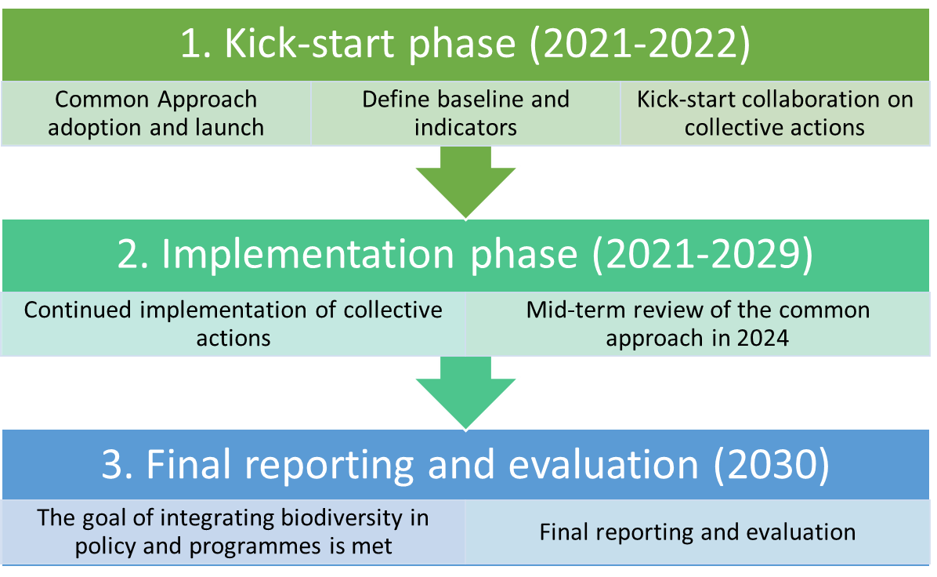
The immediate milestones in 2021, include the public launch of the report from the EMG Consultative Process and the UN Common Approach along with the development of detailed roadmaps and responsibilities for the priorities areas outlined above. These will be presented to the first meeting of the IMG on Biodiversity tentatively scheduled for 10 June 2021.
Annex 1: Summary of relevant UN Decisions

EMG processes related to biodiversity

- The Environment Management Group (EMG) is facilitating the contribution of the United Nations System to the preparation and implementation of the post-2020 global biodiversity framework, as invited by Member States. In response to this call, the 25th EMG Senior Officials Meeting (SOM) in September 2019 established an inter-agency Consultative Process composed of 51 agencies to prepare the UN system’s contribution.
- Through the EMG Consultative Process, and all 51 EMG members provided information on the relevance of biodiversity to their existing mandates, as well as to their current activities and programmes. Two contributions were prepared through EMG and submitted to the Open-Ended Working Groups to support the Post-2020 Global Biodiversity Framework. In parallel, the Consultative Process was also used to prepare a report describing the UN system’s approach to the implementation of the Framework, including a UN system high-level commitment to engage in its implementation.
- The EMG Consultative Process on Biodiversity approved the report A UN System Commitment for Action to assist Member States to deliver on the post-2020 Global Biodiversity Framework (GBF), which will be launched on 25 May 2021. The report recommends four overarching action areas in support of the 2020 Global Biodiversity Framework: (a) support country abilities to halt biodiversity loss and to sustainably use and enhance biodiversity through policies and programmes; (b) establish strong coalitions for biodiversity; (c) mainstream biodiversity in UN internal operations; and (d) enhance UN-wide coherence and follow-up on biodiversity.
- UNEP and other EMG members also responded to the SG’s requests for the UN System’s own commitment to sustainability and proposed a Strategy for Sustainability Management in the UN System 2020-2030. Phase I of the strategy, which focuses on internal environment sustainability, was endorsed at the CEB’s spring meeting in Geneva on 9th May 2019. Phase II of the strategy, coordinated by the EMG and with the scope of internal environmental and social sustainability in UN system policies, programming and facilities and operations, is now available for consultation and review. The EMG developed the Model Approach to Environmental and Social Standards for UN Programming, including a benchmark standard on Biodiversity, Ecosystems and Sustainable Natural Resource Management.
UN System decisions on biodiversity
- The Secretary General called the UN System to mainstream biodiversity work in key areas (e.g. food and agriculture, sustainable forest management, ecosystems, biosafety, governance and justice, etc.), engage in cross-agency collaboration (including by entities not traditionally involved in biodiversity work), and enhance UN communications and advocacy (Executive Committee meeting, 25 March 2020). UNEP was tasked with the implementation of the Executive Committee (EC) decision 2020/21 on biodiversity.
- The United Nations, Resolution adopted by the General Assembly on 21 December 2020. Quadrennial comprehensive policy review of operational activities for development of the United Nations system. Resolution 75/233 called upon the entities of the UN Development System (UNDS) to continue to provide evidence-based and integrated policy advice and programmatic support to help countries in the implementation of, follow-up to and reporting on the 2030 Agenda for Sustainable Development. Emphasis was placed on mainstreaming the SDGs into national plans, including by promoting sustained and inclusive economic growth, social development and environmental protection, and ending poverty in all its forms and dimensions.
- The Chief Executives Board for Coordination (CEB) meeting on 14 May 2020, endorsed a stronger focus on nature across the UN system and tasked its High-level Committee on Programmes (HLCP) to develop a common approach to integrating biodiversity and nature-based solutions for sustainable development into the UN’s policy and programme planning and delivery.
- In response to the CEB decision, the HLCP established a time-bound task team to collaborate on delivery of a common approach and collective action across the system to integrate biodiversity for sustainable development into the UN’s policy and programme planning and delivery, building on the work of the United Nations Environment Management Group (EMG) on biodiversity and other inter-agency coordination mechanisms, including drawing on current commitments by agencies, funds and programmes.
- The High-Level Committee on Programme (HLCP) at its 41st session on 30 March 2021 approved the UN Common Approach on biodiversity and nature-based solutions, which is expected to be endorsed by the Chief Executives Board for Coordination (CEB) at its meeting on 4 May 2021.

Executive Committee decision 2020/21 of 25 March 2020
Refer to Annex I enclosed for a summary of relevant UN decisions
Through the CBD COP decision 14/34 and the conclusions of the first meeting of the Open-ended Working Group on the Post-2020 Global Biodiversity Framework.
This report is the second UN System Wide Framework of Strategies on the Environment (SWFS). In November 2016, the EMG launched a survey to gather information on EMG Member Agencies’ support and contributions to the implementation of the environmental dimensions of the 2030 Agenda for Sustainable Development. In 2017 the first SWFS Synthesis Report titled ‘UN System-wide Collaboration on the Environment: Synthesis Report on UN System-wide Contributions to the Implementation of the Environmental Dimension in the Sustainable Development Goals‘ was released. It was an important inter-agency milestone as it gauged the strategic alignment of 51 UN Member Agencies to the Agenda 2030 and the UN SDGs.

